PROBLEMS:

- Translation: When we create some database or dictionary in one language the main problem that we face and that needs much effort is the translation of the data to other languages. So we will have to create a tool that will make this process easy and efficient to reduce our efforts.

SOLUTION: we can create a tool known as the translator which will automatically create a different translated tables by using translation apis of companies like Google. We will create a graphical tool that will take a table as input and enable us to mark the particular area in that table which need translation. We can choose a whole column or some area using rectangle tool to select the region in that table. After this we can simply use the translation api to translate each and every selected part in a similar structured table as that of original table. And then we will return this table as the output file.

Now our function will send request to Bharats notification function to notify some concerned authorities to check the translated values are correct or not. After that these authorities will provide a corrected table. As we have got the specific table translated into desired language we can use the solution proposed earlier by me to create a a unified table of all languages.

Our system will also have a functionality that will trigger automatic translation when a new entry is added into the system or a some modification is done to some attribute values. So this trigger will enable a function to add a correct translation for that entry ot attribute value and notify the concerned authority about the change.

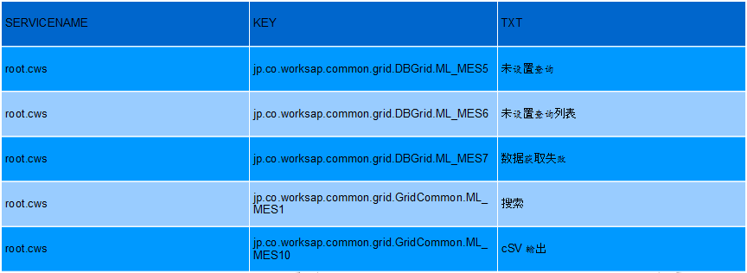
MERITS: The efforts made by the translator to add translation for each entry manually will reduce drastically and only thing that has to be done manually will be to check the translations that has been done. And that will also be notified to concerned people so it
makes system quite reliable.

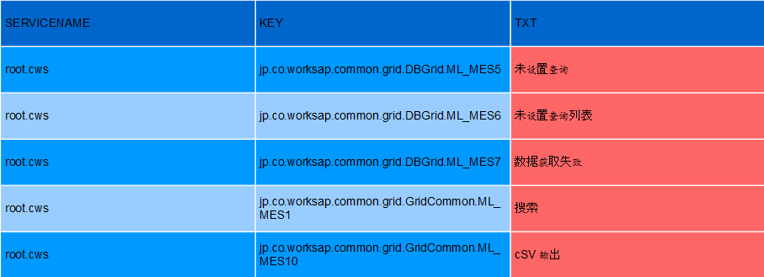
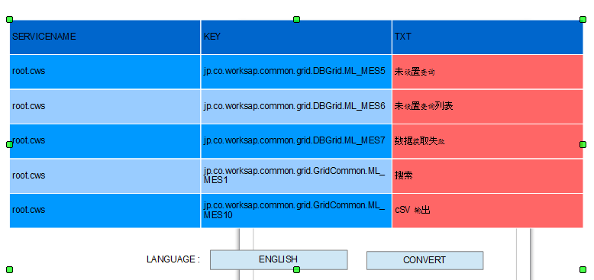

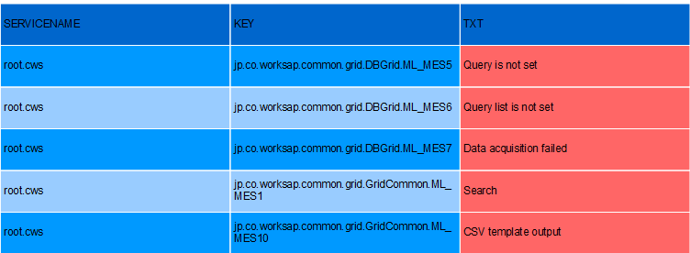

- CUSTOMER INTERACTIVE FUNCTIONS TOOL:

PROBLEM: When a customer wants to see a data or search a data. First he will have to find the data that he wants. And after finding the required data he will want to perform many operations that are similar to inherent queries in dbms. So what we can do to solve the base level customer problem?

SOLUTION : When any user logs into the system we will definitely know to which department and product he is related with. So if we know only the department of the person then we will offer him a list of product (with their description) of that department. And user will select one of them. And after that we will show him tables int the department and their description so that user can select one of table. We will also provide a custom search feature so that user can access some other department tables or product. This custom search feature will be based on keyword-description search and hiararchical graphical interface to help the user find the table in which he can exactly find the required information. We will also make user to select multiple table to have operations like join that attaches two table based on some condition.

So after finding the required table we will provide a graphical tool that will enable user to nearly have all the inherent and basic functions and feature that a database provides and user might have interest in.

I am listing some of of these feature for example

Select, Distinct, Where, And & Or, Order By, Insert Into, Update, Delete Select Top, Like, In, Between, Joins, Inner Join, Left Join, Right Join, Full Join, Union, Not Null, Unique, Alter, Auto Increment
Avg(), Count() , First() , Last(), Max(), Min(), Sum(), Group By Having Ucase(), Lcase(), Mid(), Len(), Round(), Now(), Format()

Many of these feature will be provided by our graphical tool.
User will have tutorials about the each function so that he can use them effieciently on many tables to produce the results. He can also export the result data into a file so that he can take it away if he needs it.

Merits: Now the user do not need to have technical knowledge. He can perform many inherent feature of database that can only be performed the database. So this is very useful for any user.

HOW THIS THING HELPS DIFFERENT CATEGORIES:

- Administator: As administartor may want to perform many operation related to update and addition, we take a look at following example:
Lets suppose there is a table that shows contractors and if admin wants to add the them to a new column called total. So first he will create a new column at specific position and them he will select the area over which he wants to perform the operation. Then he will select the row wise type add the columns row wise.

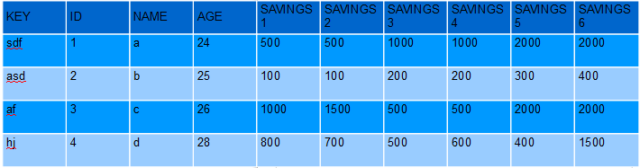
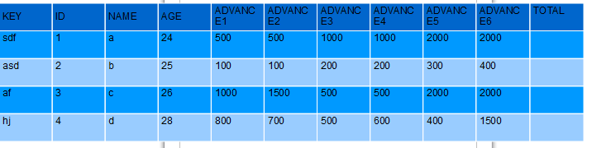
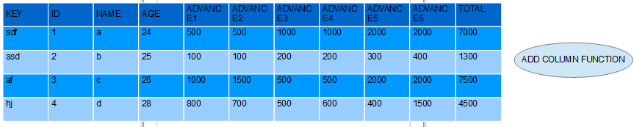

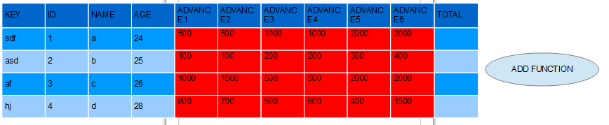

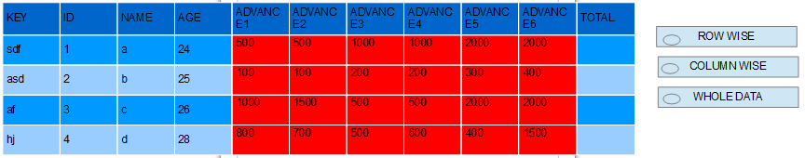

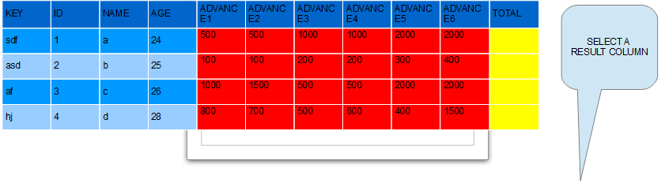
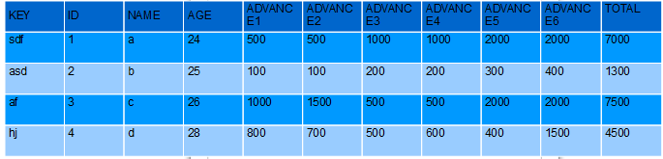

- HUMAN ASSESMENT: Lets suppose that system has four grades as A, B, C, D for employees. People with a grade A grade do the best work. B – good work, C – average work and D – worst work. The people with c, d grade work less time than that of a, b category employees. So they take long time to complete projects. So Human Assesment manager wants to scold these employess based on their project competion days as he is angree. Hence he decides to find a list of c and d grade employees with their working days in ascending manner.

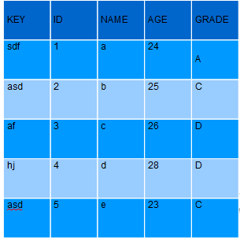
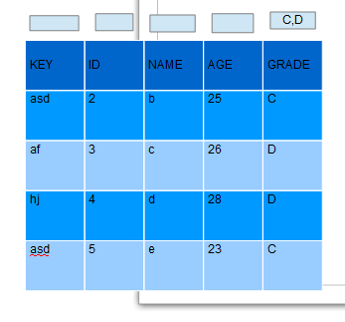

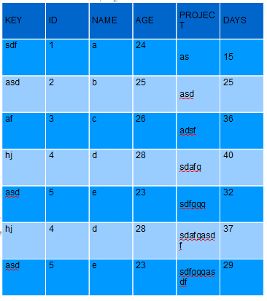

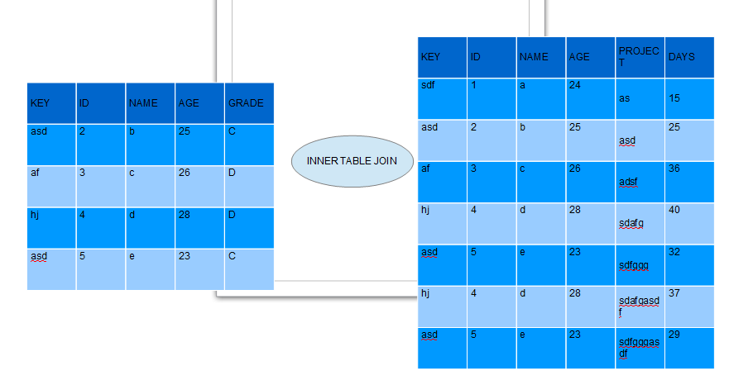

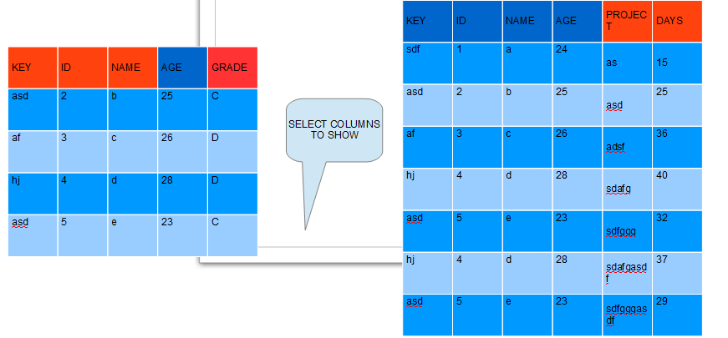

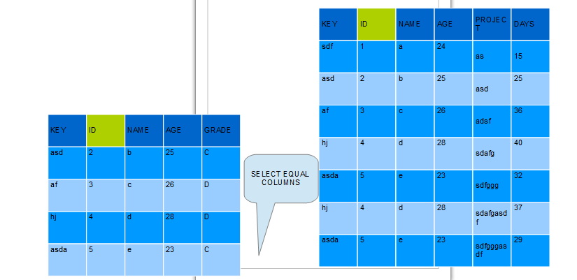

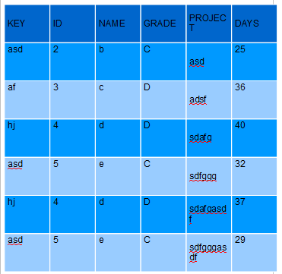

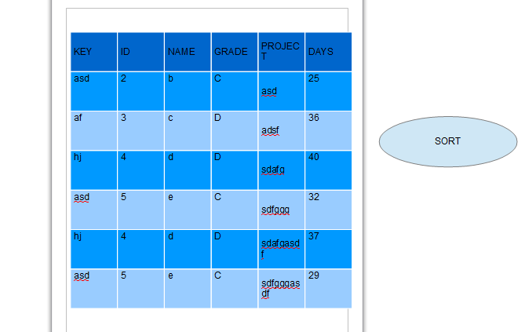
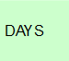

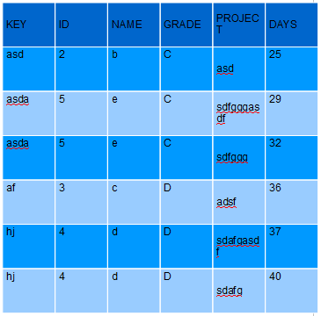

3. Customer

Like some customer wants to find all of the data that has some specific substring. So we can provide a search function like that also. We can create it by like function in dbms.

